**Page 1.**

Welcome,

VEGAS BALLERS!

INITIAL NFT OFFERING – PRESALE

MINT NFT

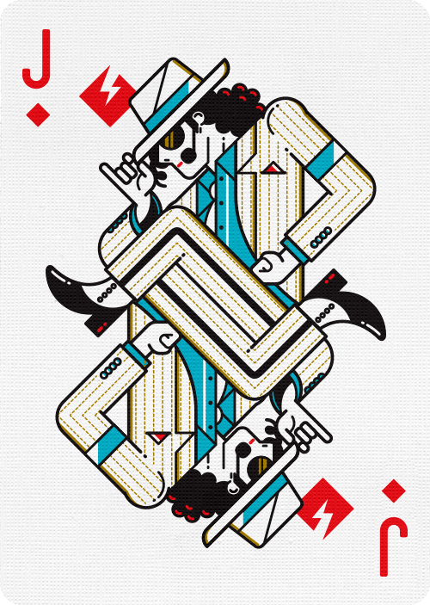

**Page 2**

IT PAYS TO HAVE A SEAT AT THIS TABLE !

An exclusive, unrivalled collection of 111 handcrafted NFT playing cards, Ultra Rare Genesis Edition, inspired by Pop and Rock LA celebrities. Kings, Queens and Jacks in the deck are some of the most important music icons from rock, soul, reggae and also first punk. Receive a bag of $MEVAX tokens when you mint a Pop Baller at presale, and earn casino profits royalties for holding this NFT. Each **VegaxClub** NFT will also be used in our Poker game launch in 2022. Do you have what it takes to become a popular Baller and sit at this table?

DELETE THIS LINE..Stay tuned Whitelist mint day is on 6 January 4 PM UTC !

**PAGE 3**

Delete this line Join the Club and Secure a Life-time share of our Casino. Be The House !

**PAGE 4**

**JOIN THE PRESALE !**

111 unique Genesis NFTs launching soon for Presale minting at 0.3 BNB each. When you mint a VegaxClub NFT, you will automatically receive equivalent BNB amount of $MEVAX Tokens and daily $MEVAX reflections for HODLing. Every single hand-drawn VegaxClub NFT has a 3D counterpart NFT to go with it to be airdropped in 2 weeks! NFT Sale aimed towards liquidity of $MEVAX Token, fair launching at the beginning of January 2021.

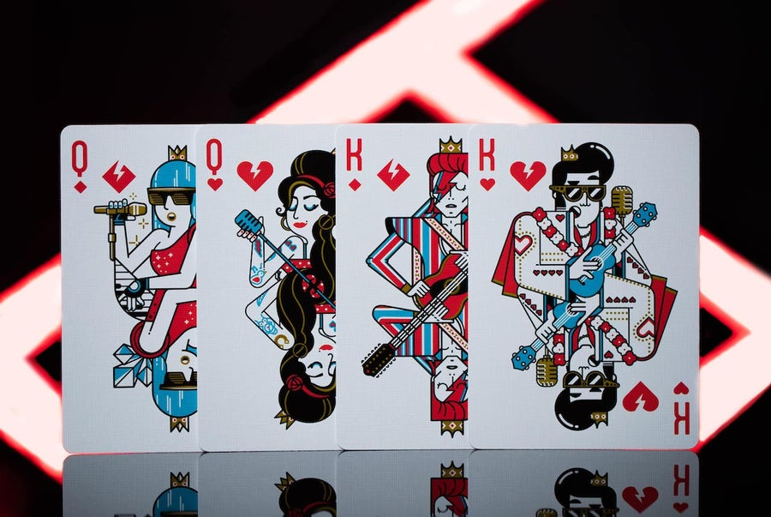

**MORE FEATURES**

CONTRIBUTED RAKEBACK

Everyone playing in the MetaVegax holding a VegaxClub NFT will be eligible for contributed Rakebacks based on the percentage of money you contribute to the pot.

WEEKLY TOURNAMENTS

Metavegax CasinoClub NFT Holders will be able to participate in our weekly tournaments for free. There will be blackjack, poker, baccarat & even horse racing tournaments taking place in our Casino & Lounges.

VIP AREAS & ACCESS

Dedicated VIP Cocktail/Lounge areas will be only accessible with a special VegaxClub NFT. In the VIP Areas you cannot only enjoy virtual drinks and have a smoke but also dance to music from different DJs or have a chat with like-minded Gamblers.

VOXELS

Owners of the NFTs will have the possibility to carry our merchandise in the Metaverse and even get rewarded.

CHARITY DONATION

We will make a monthly charity donation of 1 % of the Casinos Profits. Owners of our NFT will be able to vote which charity / organization will receive the monthly donation.

OWNERSHIP

Our holders will receive premium rates for advertising or putting portals to our Casino on their lands.